## A

**Project Report On**

**“INDIAN BANK ATM SYSTEM”**

**Submitted By**

**Miss. Nikita Gokharkar**

**Enrollment No-EONFWL388690**

**Under the Guidance of**

**Miss. Shalini Kumari.** (Technical Trainer)

**Edubridge**

### Java Full-Stack Developer

**2021**

**ACKNOWLEDGMENT**

I could never have completed my Project without the support and assistance of many people. First and foremost, I would like to express deepest gratitude to my Project guide Miss. Shalini Kumari. For her excellent guidance, valuable suggestions and kind of encouragement in Course, I will always grateful for her help.

I am also thankful to EduBridge. Last but not the least I would like to owe a debt to my parents who are the silent guides in my life. I am also thankful to all my friends for their encouragement and support.

Nikita Rashmikant Gokharkar. (Enrollment no-EONFWL388690)

**Content**

1. Introduction
   1. Software Requirement
2. Problem Definition
   1. Java concept
3. Flow Diagram
4. Output
5. Advantages
6. Conclusion

**CHAPTER 1**

## INTRODUCTION

Generally, banking system has been working continuously for many years. Cash or paper money has been the payment mechanism for centuries in nationwide. In traditional banking methods customer will need to interact with the cashier which will be appointed by the bank to handle bank services such as withdraw money or to deposit the cash. This Project Indian ATM Bank Systemhas been developed to overcome these problems**.** The purpose of this system is to manage and maintain the customer bank account details.

In this system there are two different types of account the Saving account and Checking account, where the customer can view the balance, deposite and withdraw the money from their account. The project is build using Java language. Also the project is user friendly.

### Software Requirement:

**Front End :** Java

**IDE :** Eclipse IDE

**Operating System :** Windows 10.

# CHAPTER 2

## PROBLEM DEFINITION

This System is develop for to maintain and manage the record of customer bank accounts.

In this system customer has to login by the customer id and password, if any of them is wrong the customer will not be able to get into their about account. They have to choose whether they have to choose the checking account or the saving account by entering choice 1 or 2. Then a list will be displayed from which they can choose whether to view the account balance, deposite the money in their account or withdraw the money from the account. If a customer tries to withdraw more money from the account a message will be displayed saying “Balance cannot be negative” . It also calculate the balance left in account, and the amount after depositing and withdrawing the money in the account.

This project not only keeps the record of various people but also it reduces the extensive paper work with present system.

### Following Java Concept are used in this project

1. Switch Case
2. Inheritance
3. Exception
4. Collection

**Following Classes are used:**

* 1. ATM
  2. Menu
  3. AccountInfo

**CHAPTER 3**

**FLOW DIAGRAM**

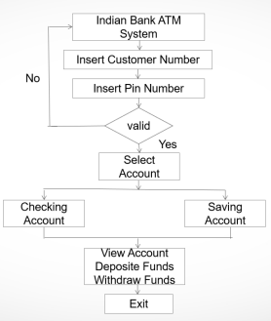

**CHAPTER 4**

**OUTPUT**

* Enter the Customer Number
* Enter the Pin Number

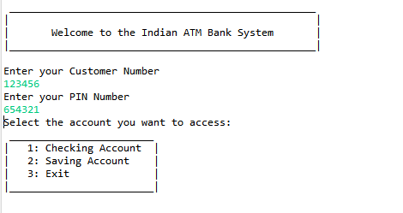

* Enter the choice

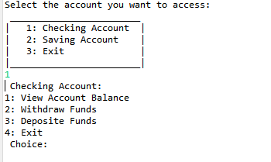

* Display the current amount in the account

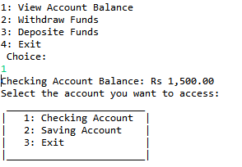

* Withdraw money from the exsisting money from the account

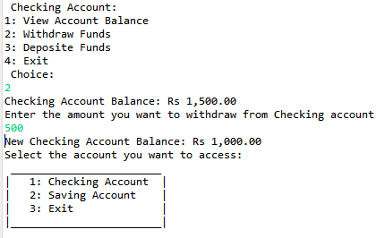

* Depositing the money in the account

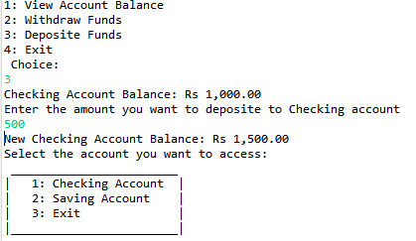

* Withdraw amount cannot be less than the amount in the account

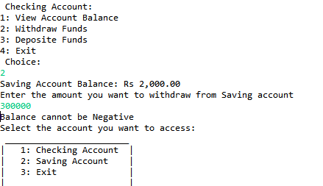

**CHAPTER 5**

**ADVANTAGES AND CONCLUSION**

**Advantages :**

* Manual errors are eleminated.
* User Friendly
* Easy management
* Can be accessed from anywhere.

**Conclusion :**

This system is proposed for managing and maintaining customer bank details This is user friendly and many functionality are provided to the user to manage their account.